**Exercise:**

The first exercise is a warm up question to make your understanding of reading from and writing to a txt file.

**Question:**

Firstly create a txt file (file name: students) and write 5 names into the file line by line. Then read and output all the names from this file. After executing the project, you will have a student.txt file in the folder of the project.

Sample txt.file:

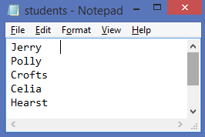

Sample output:

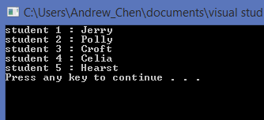

Ps. You may need a counter outside the while loop to keep counting the number of reading

Input.